ASK BEHAVIORAL QUESTION – (THINK BIG)
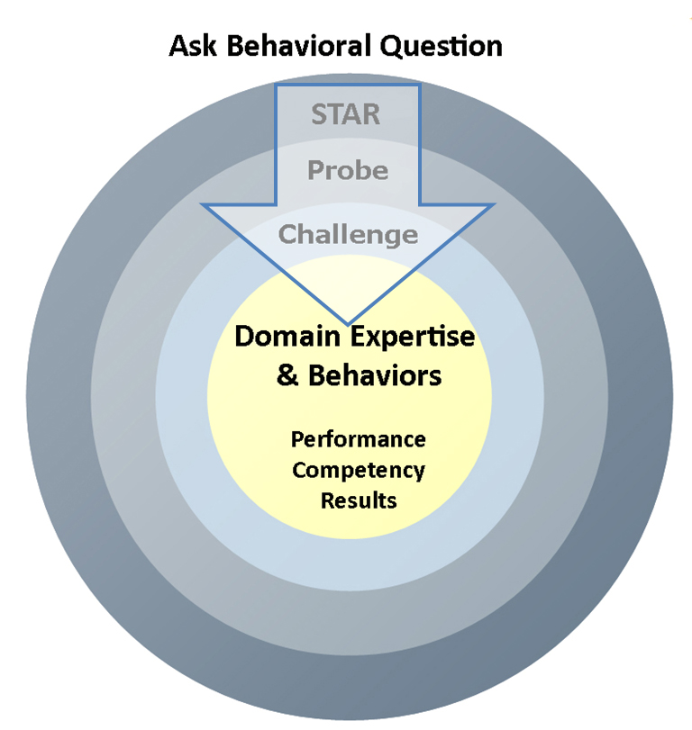
Q: Give me an example of a big decision you made in the last year that had significant impact on your customers.

STAR - Get the full story (1st Layer)

Situation/Task:
Qs: What was the situation behind this decision and the reason why it was so important to make a good decision?

Action:
Qs: What data did you draw from to make this decision? Who else did you involve in this decision and what contribution did they make to shape your thinking process? If there wasn't good data, what did you do in the absence of data?

Result:
Qs: How did you communicate the decision? What was the acceptance and response to the decision and how did you work through that? What was the final outcome?

PROBE - Go deep on your Leadership Principle (2nd Layer)
Use the Think Big Definition as a prompt for questions: Thinking small is a self-fulfilling prophecy. Leaders create and communicate a bold direction that inspires results. They think differently and look around corners for ways to serve customers.
Qs: What ways did you think differently to serve your customers? Would you consider your decision to be a bold direction for the company/department? How?
CHALLENGE – Learn how the candidate thinks and performs (3rd Layer)
- Now that you’ve finished probing Think Big, challenge the candidate with its counterbalance, Dive Deep. At Amazon, we need to hire people who can Think Big AND Dive Deep.
Use the Dive Deep Definition as a prompt for questions: Leaders operate at all levels, stay connected to the details and audit frequently. No task is beneath them.

Qs: How do you know that your decision was fully implemented? How did you stay connected to the execution of the decision? What did you personally get involved with to drive the results? What did you discover about your team as they were executing on this goal? What gave you the most satisfaction in this process?

- To challenge the candidate, you could also pursue and confront any yellow or red flags that you encountered in the candidate’s story/statements.

Qs: You mentioned that you thought your boss was ineffective in this project tell me why you thought that? What role did you expect your manager to play? Did you make that role clear? What did you try to get your boss involved?

- To challenge the candidate, you could ask the candidate how they would improve their decision, process or product now.

Qs: What were their lessons learned? What technologies would they employ now that they didn’t have then?

- Another way to challenge the candidate is to challenge the decisions or actions in the story itself.

Qs: You mentioned that you decided to go with a short-term, low cost approach to get the product to market quickly yet it caused quality problems and customer contacts. Why didn’t you extend your launch to have a better product for your customer at the onset?

